**JavaScript HandsOn 2**

**1. Create a function that prints/logs all the integers from 1 to 20.**

###### **Test Cases (0/1)**

* 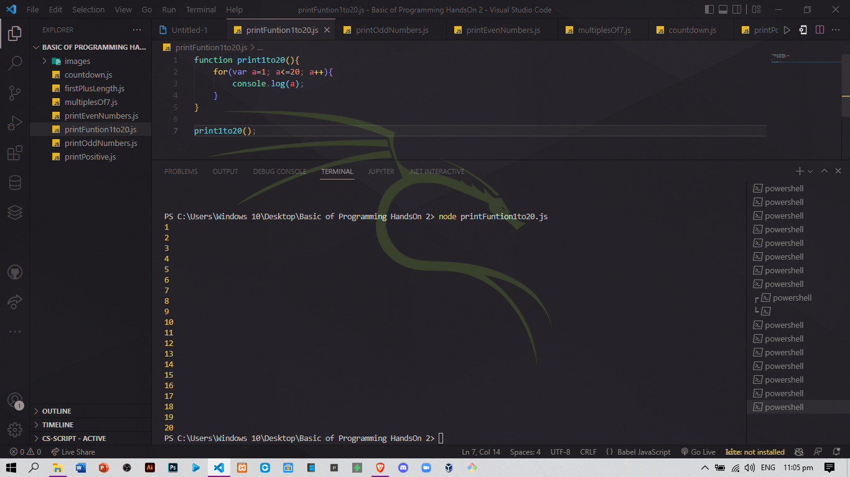print1to20() to log 1 2 3 4 5 6 7 8 9 10 11 12 13 14 15 16 17 18 19 20

**2. Create a function that prints/logs all the odd numbers from 3 to 20.**

###### **Test Cases (0/1)**

* printOdd3to20() to log 3 5 7 9 11 13 15 17 19

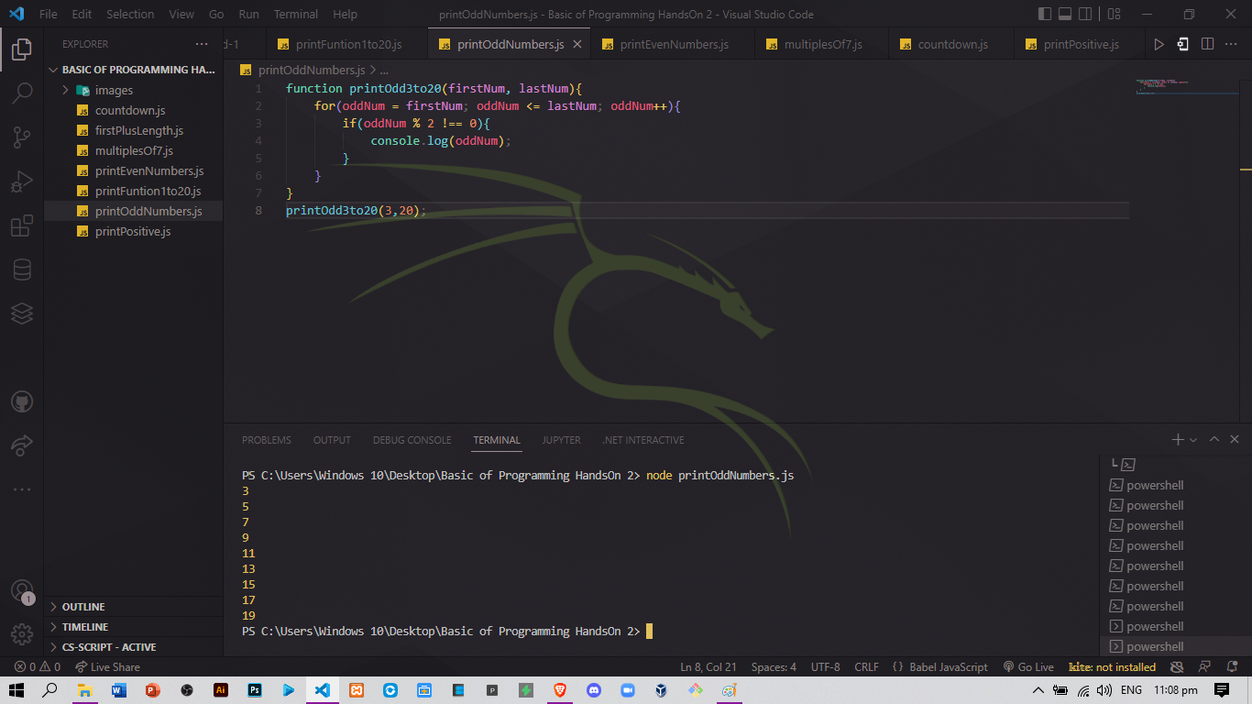

**3. Create a function that prints/logs all the even numbers from 4 to 22.**

###### **Test Cases (0/1)**

* printEven4to22() to log 4 6 8 10 12 14 16 18 20 22

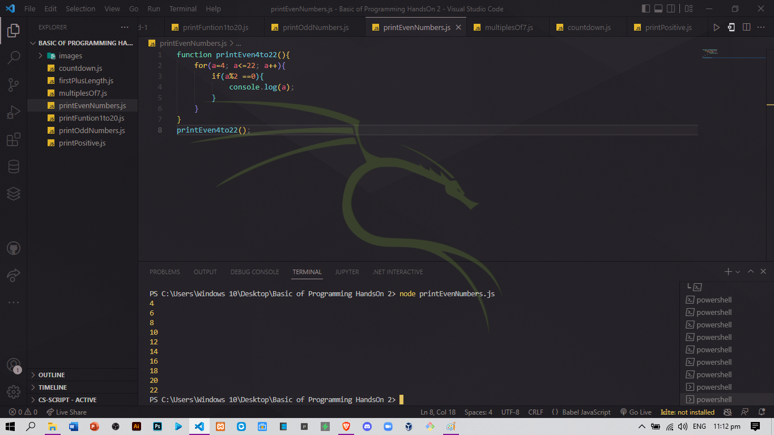



**4. Print/log all the multiples of 7 between the numbers 7 to 62.**

###### **Test Cases (0/1)**

* multiplesOf7() to log 7 14 21 28 35 42 49 56

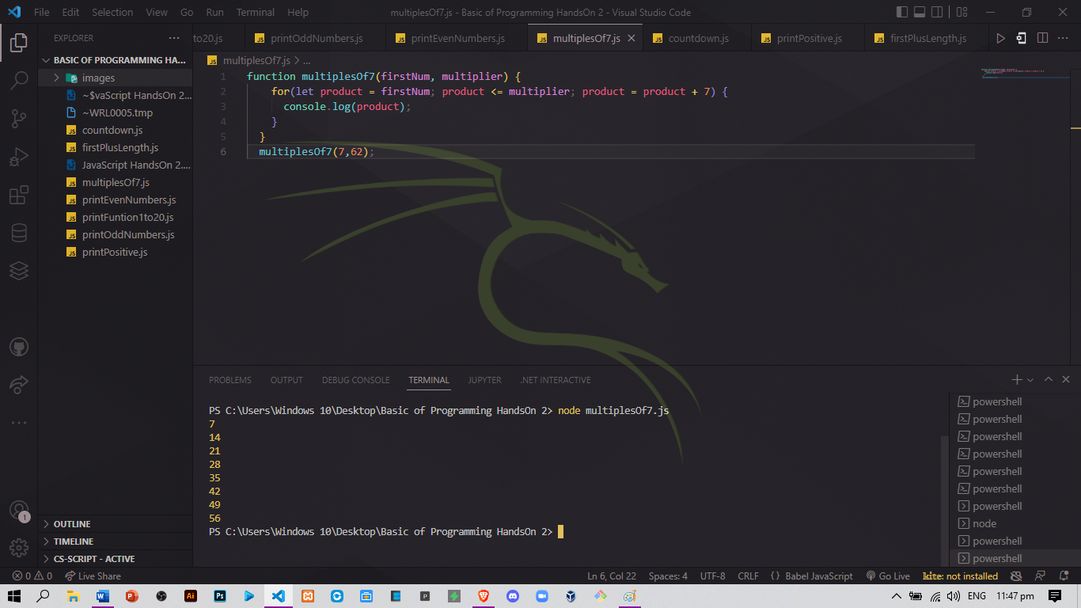

**5. Log positive numbers starting at 50, counting down by fives (exclude 0).**

###### **Test Cases (0/1)**

* countdownByFives() to log 50 45 40 35 30 25 20 15 10 5

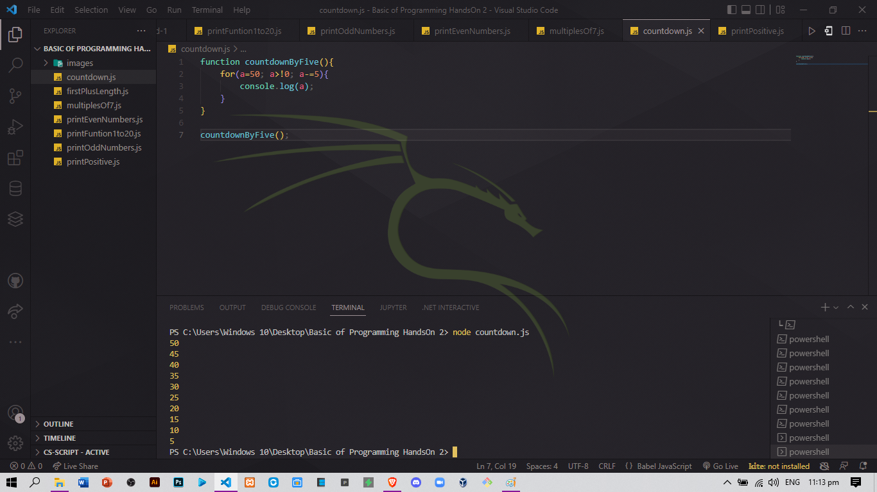

**6. Given an array, print/log the sum of the first value in the array, plus the array’s length. Assume that the array is composed of numbers.**

###### **Test Cases (0/4)**

* firstPlusLength([1,2,5]) to log 4
* firstPlusLength([3,0,2,5]) to log 7
* firstPlusLength([-5,0,2,5]) to log -1
* firstPlusLength([1]) to log 2

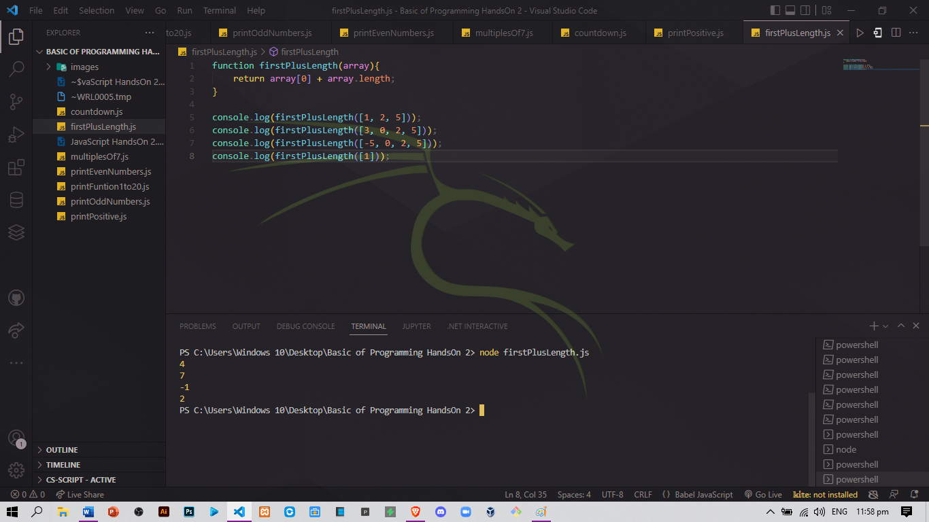

**7. Given an array, write a function that prints the index value of its positive values.**

For example, printPositiveIndex([1, 3, -10]), have it print/log 0, 1 (as the 0th index had a positive value and index 1 also had a positive value).

printPostiiveIndex([10, 5, -5, 15]) should print/log 0, 1, and 3. In other words, it prints the index of each positive number in the array.

###### **Test Cases (0/3)**

* printPositiveIndex([1, 3, -10]) to log 0 1
* printPositiveIndex([10, 5, -5, 15]) to log 0 1 3
* printPositiveIndex([10, 5, 5, 15]) to log 0 1 2 3

